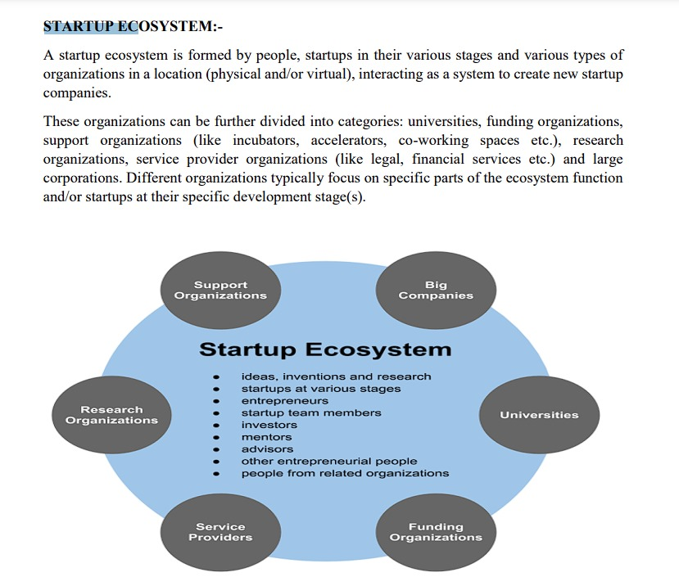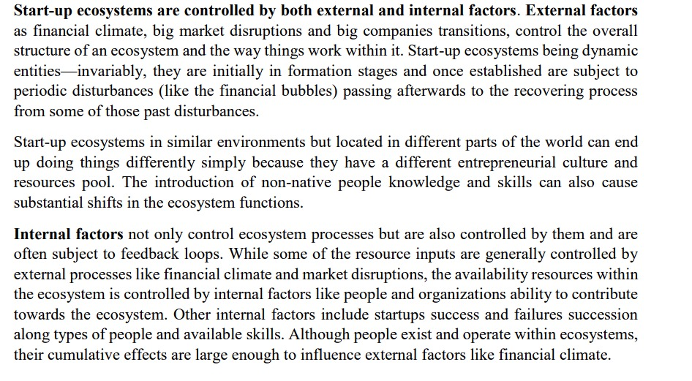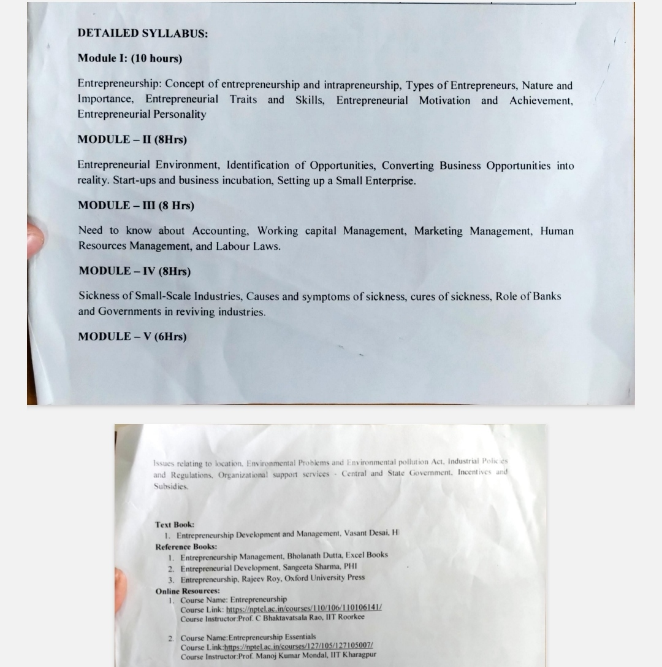

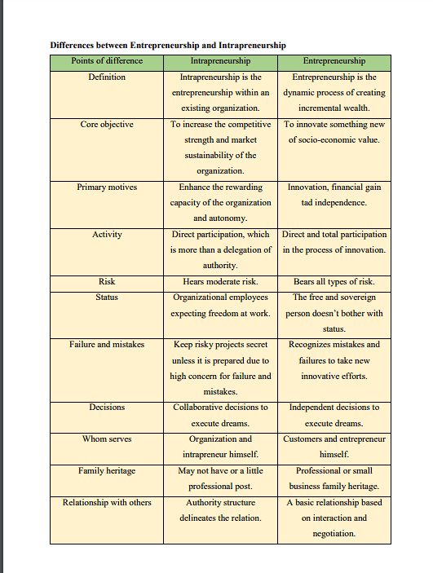

***Nature of Entrepreneur***

**Creation Of Enterprise**

Entrepreneurship is a process that refers to the creation and running of a new enterprise. It is an activity under which a person called an entrepreneur starts a new venture using a new idea.

**Economic Activity**

Entrepreneurship is an economic activity as it involves creating and running a new business through optimum utilization of all combined resources. It ensures that all scarce resources are efficiently used for deriving better returns in the form of profit.

**Innovation And Creativity**

It is the process of discovering new ideas and concepts and implementing them in business ventures. Entrepreneurship involves bringing innovation in the market by introducing new products or process that delivers better service.

**Risk Bearing**

It is an activity which involves huge risk which every entrepreneur needs to undertake for starting a venture. New ideas developed and implemented by the entrepreneur are uncertain and may result in losses.

**Profit**

Profit earning is the sole objective of an entrepreneur for undertaking risk. Entrepreneurs start a new venture with a view to earning profits.

**Gap Filling**

Entrepreneurship is a process of recognizing and filling the gap between customer needs and available products or services. It focuses on removing the deficiencies from the currently available products to fulfill the needs of customers.

**Organizing Function**

It is an organizing function that brings together different factors of production like land, labor, and capital. Entrepreneurship is concerned with coordinating and managing all resources engaged within the enterprise.

**Importance of Entrepreneurship**

**Development Of Managerial Capabilities**

1. **Self -Contentment:**Entrepreneurs have a high commitment towards their goals and they have the caliber to take charge of the situation. It gives opportunity to an individual to contribute towards social goods by his Innovative ways.
2. **Financial benefits and secured life**: There is immense probability of reaping financial towards through better products. Entrepreneurial rewards may surpass the benefits of some of the best paid jobs.
3. **Social acceptance and recognition:** it gives prestige and status to the individual and inspire other innovative minds to take initiatives.

**Creation Of Organisations**

Entrepreneurship results into creation of organisations when entrepreneurs assemble and coordinate physical, human and financial resources and direct them towards achievement of objectives through managerial skills.

**Improving Standards Of Living**

By creating productive organisations, entrepreneurship helps in making a wide variety of goods and services available to the society which results into higher standards of living for the people. Possession of Luxury cars, computers, mobile phone, rapid growth of shopping malls, etc. are pointers to the rising living standards of people, and all this in due to the efforts of entrepreneurs.

**Means Of Economic Development:**

Entrepreneurship involves creation and use of innovative ideas, maximization of output from given resources, development of managerial skills, etc, and all these factors are very essential for the economic development of a country. It achieves following:

1. **Job Creation:** Increased production activities require additional workforce at all levels of management and for all different streams. Creation of job is a strong indicator of sustainable economic growth.
2. **Self-reliant economy**: Small businesses help individuals to grow financially independent. This in turn lends to the development of a resurgent middle class and a self-reliant economy.
3. **Export Promotion:** Entrepreneurs can attempt to penetrate new markets and establish themselves as global brands.

3.**Entrepreneurial Traits:**

1. **Creativity**: Entrepreneurs often need to think creatively to come up with innovative solutions to problems, design unique products or services, and differentiate themselves in the market. Creativity enables entrepreneurs to see opportunities where others may not, leading to the development of disruptive business ideas and strategies.
2. **Resilience**: The entrepreneurial journey is filled with challenges, setbacks, and failures. Resilient entrepreneurs possess the mental toughness and perseverance to overcome obstacles, learn from failures, and keep moving forward despite adversity. Resilience allows entrepreneurs to maintain a positive attitude, adapt to change, and ultimately achieve long-term success.
3. **Adaptability**: Markets, technologies, and consumer preferences are constantly evolving. Successful entrepreneurs are adaptable and flexible, willing to pivot their business strategies, adjust to market conditions, and embrace change. Adaptability enables entrepreneurs to stay ahead of the curve, seize new opportunities, and thrive in dynamic and unpredictable environments.
4. **Vision**: A clear vision provides entrepreneurs with a sense of purpose and direction, guiding their decisions and actions as they work towards their goals. Visionary entrepreneurs can see beyond the present circumstances, envisioning a future that is different and better than the status quo. They inspire others to join their journey by articulating their vision and rallying support behind their mission.
5. **Risk-taking**: Entrepreneurship inherently involves taking risks, whether financial, personal, or professional. Successful entrepreneurs are willing to take calculated risks, stepping out of their comfort zones to pursue opportunities with uncertain outcomes. Risk-taking is essential for innovation, growth, and achieving breakthroughs that lead to business success.
6. **Passion**: Passion fuels the entrepreneurial spirit, driving entrepreneurs to pursue their goals with enthusiasm, determination, and energy. Passionate entrepreneurs are deeply committed to their ideas, products, or services, investing their time, effort, and resources wholeheartedly into their ventures. Passion sustains motivation, inspires perseverance, and empowers entrepreneurs to overcome challenges on their journey.
7. **Leadership**: Effective leadership is essential for guiding teams, making tough decisions, and driving business growth. Entrepreneurial leaders inspire trust, motivate others, and create a positive work culture that fosters collaboration, creativity, and innovation. Leadership skills such as communication, delegation, problem-solving, and empathy are critical for building high-performing teams and achieving collective goals.

**Entrepreneurial Skills:**

1. **Financial acumen**: Understanding financial concepts such as budgeting, forecasting, cash flow management, and financial analysis is crucial for making informed decisions, managing resources effectively, and ensuring the financial health of the business. Financial acumen enables entrepreneurs to allocate resources strategically, assess investment opportunities, and navigate financial challenges with confidence.
2. **Time management**: Entrepreneurs often juggle multiple tasks, deadlines, and priorities simultaneously. Effective time management involves setting goals, prioritizing tasks, delegating responsibilities, and minimizing distractions to maximize productivity and efficiency. Time management skills enable entrepreneurs to focus their efforts on high-impact activities, meet deadlines, and achieve their objectives in a timely manner.
3. **Strategic planning**: Developing a clear business strategy involves setting goals, analyzing market trends, identifying opportunities and threats, and formulating action plans to achieve sustainable growth and competitive advantage. Strategic planning enables entrepreneurs to align their resources and efforts with their long-term vision, anticipate changes in the market, and capitalize on emerging opportunities.
4. **Marketing and sales**: Successful entrepreneurs understand the importance of marketing and sales in reaching customers, promoting their products or services, and generating revenue. Marketing skills include branding, market research, advertising, and digital marketing, while sales skills involve prospecting, negotiation, relationship-building, and closing deals. Marketing and sales expertise enable entrepreneurs to attract and retain customers, drive business growth, and differentiate their offerings in the marketplace.
5. **Negotiation**: Entrepreneurs often negotiate with investors, suppliers, partners, employees, and other stakeholders. Negotiation skills involve effective communication, problem-solving, active listening, and the ability to reach mutually beneficial agreements that support the interests of all parties involved. Negotiation skills enable entrepreneurs to secure favorable deals, resolve conflicts, and build strong relationships that contribute to the success of their ventures.
6. **Decision-making**: Entrepreneurship requires making tough decisions under uncertainty and pressure. Effective decision-making involves gathering relevant information, analyzing alternatives, weighing risks and rewards, and choosing the best course of action to achieve desired outcomes. Decision-making skills enable entrepreneurs to assess opportunities, mitigate risks, and navigate complex situations with confidence and clarity.
7. **Team building and management**: Building a talented and cohesive team is essential for scaling a business and achieving long-term success. Entrepreneurial leaders must recruit, train, motivate, and empower team members, fostering a positive work environment and leveraging the diverse skills and perspectives of their employees. Team building and management skills enable entrepreneurs to build high-performing teams, delegate effectively, and cultivate a culture of collaboration, trust, and accountability within their organizations.

**Entrepreneurial Motivation:**

1. **Passion:** Entrepreneurs are often fueled by a deep passion for their business idea or vision. This intrinsic motivation provides the energy and dedication needed to navigate the challenges of entrepreneurship and pursue their goals relentlessly.
2. **Autonomy:** The desire for autonomy and independence drives many individuals to entrepreneurship. The ability to make their own decisions, chart their own course, and control their destiny appeals to those who seek freedom from traditional corporate structures.
3. **Impact:** Many entrepreneurs are motivated by a desire to make a positive impact on the world. Whether it's solving a pressing problem, improving people's lives, or contributing to social or environmental causes, the opportunity to create meaningful change drives their entrepreneurial pursuits.
4. **Financial Goals:** Financial incentives play a significant role in motivating entrepreneurs. The potential for wealth creation, financial independence, and higher earning potential motivates individuals to take calculated risks and invest their time and resources into building successful businesses.
5. **Challenge and Growth:** Entrepreneurship offers a dynamic and challenging environment that appeals to individuals seeking personal and professional growth. The opportunity to learn new skills, overcome obstacles, and push the boundaries of their capabilities motivates entrepreneurs to embrace the uncertainties and risks of entrepreneurship.
6. **Freedom to Innovate:** Entrepreneurs value the freedom to innovate and bring their creative ideas to fruition without the constraints of traditional corporate structures. The ability to experiment, iterate, and innovate drives entrepreneurs to pursue opportunities for disruptive change and innovation in their industries.
7. **Legacy:** Some entrepreneurs are motivated by a desire to leave a lasting legacy. Whether it's building a successful business empire, pioneering groundbreaking innovations, or leaving a positive impact on future generations, the opportunity to create a legacy that outlives them serves as a powerful motivator for their entrepreneurial endeavors.

**Entrepreneurial Achievement:**

1. **Business Launch:** The successful launch of a new business venture represents a significant achievement for an entrepreneur. From conceptualization to execution, turning an idea into a tangible business entity requires dedication, perseverance, and strategic planning.
2. **Revenue Generation:** Generating revenue and achieving financial milestones validate the viability and sustainability of a business. Successfully attracting customers, generating sales, and driving revenue growth demonstrate market demand for the product or service and contribute to the financial success of the venture.
3. **Customer Acquisition:** Acquiring customers and building a loyal customer base is essential for the long-term success of any business. Successfully attracting and retaining customers through effective marketing, sales, and customer service efforts signifies the value proposition of the business and its ability to meet customer needs.
4. **Innovation:** Entrepreneurial achievement often involves the development and innovation of new products, services, or solutions that address unmet needs or create value for customers. Introducing innovative offerings to the market can differentiate the business from competitors, drive growth, and enhance its competitive advantage.
5. **Market Expansion:** Expanding into new markets, geographic regions, or customer segments represents a significant achievement for entrepreneurs looking to scale their businesses. Successfully penetrating new markets and reaching untapped opportunities can fuel business growth and unlock new revenue streams.
6. **Team Building and Leadership:** Building a talented and cohesive team, and providing effective leadership, are critical achievements for entrepreneurs. A high-performing team aligned with the company's vision and values can drive productivity, innovation, and overall business success.
7. **Recognition:** Entrepreneurial achievements are often recognized and celebrated through industry awards, accolades, and media recognition. External validation and acknowledgment of the entrepreneur's accomplishments can boost morale, enhance credibility, and attract further opportunities for growth and success.

**Successful Entrepreneur Personality Traits**

1. **Discipline**: Successful entrepreneurs exhibit discipline in their daily routines, work habits, and decision-making processes. They set clear goals, prioritize tasks, and stay focused on achieving results despite distractions or setbacks.
2. **Creativity**: Creativity is essential for entrepreneurs to innovate, problem-solve, and differentiate their businesses in competitive markets. Successful entrepreneurs think outside the box, generate novel ideas, and find unique solutions to challenges.
3. **Self-Awareness**: Self-awareness enables entrepreneurs to understand their strengths, weaknesses, motivations, and limitations. Successful entrepreneurs leverage self-awareness to make informed decisions, capitalize on their strengths, and seek support or development in areas of weakness.
4. **Resourcefulness**: Entrepreneurs often face constraints in terms of time, money, and resources. Successful entrepreneurs are resourceful, finding creative ways to overcome obstacles, leverage available resources, and maximize efficiency in achieving their goals.
5. **Process-Oriented**: Successful entrepreneurs understand the importance of establishing efficient processes and systems to streamline operations, improve productivity, and scale their businesses. They prioritize organization, standardization, and continuous improvement to drive sustainable growth.
6. **Empathetic**: Empathy is crucial for building strong relationships with customers, employees, and stakeholders. Successful entrepreneurs understand the needs, feelings, and perspectives of others, allowing them to anticipate customer preferences, motivate employees, and foster trust and loyalty.
7. **Communicative**: Effective communication is essential for conveying ideas, building relationships, and aligning teams toward common goals. Successful entrepreneurs are skilled communicators who can articulate their vision, inspire others, and navigate complex interpersonal dynamics with clarity and empathy.
8. **Self-Motivated**: Entrepreneurship requires a high degree of self-motivation and initiative. Successful entrepreneurs possess an internal drive to pursue their goals, overcome obstacles, and persist in the face of challenges without external supervision or incentives.
9. **Confident**: Confidence is a key trait of successful entrepreneurs, enabling them to make bold decisions, take calculated risks, and lead with conviction. Confidence in oneself and one's abilities inspires trust and credibility, attracting customers, investors, and collaborators to the entrepreneur's vision.
10. **Flexible**: Adaptability and flexibility are essential for navigating the uncertainties and rapid changes inherent in entrepreneurship. Successful entrepreneurs embrace change, pivot their strategies when necessary, and seize opportunities in dynamic and evolving environments.
11. **Risk-Taker**: Entrepreneurship inherently involves taking risks, whether financial, personal, or professional. Successful entrepreneurs are comfortable with uncertainty and ambiguity, willing to take calculated risks to pursue opportunities and achieve their goals.
12. **Resilient**: Resilience is the ability to bounce back from setbacks, failures, and adversity. Successful entrepreneurs face numerous challenges on their journey and demonstrate resilience by learning from failures, staying optimistic, and persisting in their efforts to achieve long-term success.

The Scope of HRM

The scope of HRM is very wide. It consists of all the functions that come under the banner of

human resource management. The different functions are as follows:-

1.Human Resources Planning

It is the process by which a company identifies how many positions are vacant and

whether the company has excess staff or shortage of staff and subsequently deals with

this need of excess or shortage.

2.Job Analysis Design

Job analysis can be defined as the process of noticing and regulating in detail the

particular job duties and requirements and the relative importance of these duties for a

given job.

Job analysis design is a process of designing jobs where evaluations are made regarding

the data collected on a job. It gives an elaborate description about each and every job in

the company.

3.Recruitment and Selection

With respect to the information collected from job analysis, the company prepares

advertisements and publishes them on various social media platforms. This is known as

recruitment.

A number of applications are received after the advertisement is presented, interviews are

conducted and the deserving employees are selected. Thus, recruitment and selection is

yet another essential area of HRM.

**4.Orientation and Induction**

After the employees are selected, an induction or orientation program is organized. The

employees are updated about the background of the company as well as culture, values,

and work ethics of the company and they are also introduced to the other employees.

5.Training and Development

Employees have to undergo a training program, which assists them to put up a better

performance on the job. Sometimes, training is also conducted for currently working

experienced staff so as to help them improve their skills further. This is known as

refresher training.

6.Performance Appraisal

After the employees have put in around 1 year of service, performance appraisal is

organized in order to check their performance. On the basis of these appraisals, future

promotions, incentives, and increments in salary are decided.

7.Compensation Planning and Remuneration

Under compensation planning and remuneration, various rules and regulations regarding

compensation and related aspects are taken care of. It is the duty of the HR department

to look into remuneration and compensation planning.

**EDP's**: EDP stands for Entrepreneurship Development Programs. These are training programs designed to develop and enhance entrepreneurial skills and abilities among individuals interested in starting or managing their own businesses.

**EDP's Process**:

1. **Identification**: Identifying potential participants who are interested in entrepreneurship.
2. **Training**: Providing participants with knowledge and skills related to various aspects of entrepreneurship, such as business planning, marketing, financial management, and networking.
3. **Mentoring**: Offering guidance and support from experienced entrepreneurs or mentors.
4. **Networking**: Facilitating connections and networking opportunities with other entrepreneurs, industry experts, and potential partners or investors.
5. **Follow-up Support**: Providing ongoing support, resources, and assistance even after the completion of the program.

**Objectives of EDPs**:

1. **To Cultivate Entrepreneurial Skills**: EDPs aim to nurture and develop entrepreneurial skills such as creativity, innovation, risk-taking, and decision-making among participants.
2. **To Facilitate Business Start-ups**: The primary goal of EDPs is to empower individuals to successfully start and manage their own businesses.
3. **To Foster Economic Growth**: By promoting entrepreneurship and facilitating the establishment of new ventures, EDPs contribute to economic growth, job creation, and wealth generation in the society.

**Contents of EDPs**: The contents of EDPs typically include:

1. Entrepreneurship Concepts and Theories
2. Business Planning and Development
3. Marketing Strategies
4. Financial Management and Funding Options
5. Legal and Regulatory Compliance
6. Risk Management
7. Networking and Collaboration Skills
8. Leadership and Management Skills

**Role of government & non-governmental agencies in promoting entrepreneurship in India**: Both government and non-governmental agencies play crucial roles in promoting entrepreneurship in India:

1. **Government**: The government provides various incentives, schemes, and support programs to encourage entrepreneurship, such as financial assistance, subsidies, tax benefits, and infrastructure development. It also formulates policies and regulations conducive to business start-ups and growth.
2. **Non-governmental agencies**: NGOs, industry associations, and entrepreneurial support organizations offer training, mentorship, networking opportunities, and access to resources for aspiring entrepreneurs. They also advocate for the interests of entrepreneurs and facilitate collaboration between different stakeholders in the entrepreneurial ecosystem.

**Characteristics of a successful Training Programme**:

1. **Relevance**: The training program should address the specific needs and challenges faced by entrepreneurs in their respective industries or sectors.
2. **Engagement**: It should be interactive, engaging, and practical, providing hands-on experience and real-world examples.
3. **Expertise**: The program should be delivered by experienced trainers or industry experts who can offer valuable insights and guidance.
4. **Support**: There should be ongoing support and follow-up mechanisms to assist participants in applying their learning and overcoming obstacles.
5. **Evaluation**: The effectiveness of the training program should be regularly evaluated and adjusted based on feedback and outcomes.

**Small Scale Industries (SSI)**: Small Scale Industries, also known as Micro, Small, and Medium Enterprises (MSMEs) in India, are businesses characterized by relatively small investment in plant and machinery. They play a significant role in the economic development of the country by providing employment opportunities, fostering entrepreneurship, and contributing to industrial production and exports.

**Two Objectives of Small Enterprises**:

1. **Employment Generation**: Small enterprises aim to create job opportunities, particularly in rural and semi-urban areas, thereby reducing unemployment and poverty.
2. **Promotion of Local Industries**: Small enterprises contribute to the development of local industries and entrepreneurship by utilizing local resources, fostering innovation, and meeting the needs of local markets.



**You**

Discuss the knowledge and skill required for an entrepreneur.

ChatGPT

**ChatGPT**

Entrepreneurship requires a combination of knowledge, skills, and abilities to successfully start and manage a business venture. Here's a detailed discussion on the knowledge and skills required for an entrepreneur:

**Knowledge:**

1. **Industry Knowledge**: Understanding the specific industry or market in which the business operates is crucial for identifying opportunities, predicting trends, and making informed decisions.
2. **Market Research**: Knowledge of market research techniques helps entrepreneurs assess customer needs, competition, and market demand for their products or services.
3. **Financial Literacy**: Entrepreneurs need to have a solid understanding of financial concepts such as budgeting, cash flow management, profit margins, and financial statements to effectively manage the financial aspects of their business.
4. **Legal and Regulatory Knowledge**: Familiarity with business laws, regulations, and compliance requirements is essential for ensuring that the business operates legally and avoids potential legal issues.
5. **Product or Service Expertise**: In-depth knowledge about the products or services offered by the business is necessary for delivering value to customers, refining offerings, and staying ahead of competitors.
6. **Technology Awareness**: Awareness of emerging technologies relevant to the industry can help entrepreneurs leverage innovation, automate processes, and stay competitive in the market.

**Skills:**

1. **Creativity and Innovation**: Entrepreneurs need to be creative in generating new ideas, products, or business models and innovative in solving problems and addressing market needs in unique ways.
2. **Communication Skills**: Effective communication skills are essential for conveying ideas, building relationships with customers, investors, and employees, and negotiating deals.
3. **Leadership and Management**: Strong leadership skills are required to inspire and motivate teams, delegate tasks, and make strategic decisions. Effective management skills help in organizing resources, setting goals, and achieving objectives.
4. **Decision-Making**: Entrepreneurs must possess good decision-making skills to evaluate options, analyze risks, and choose the best course of action for the business.
5. **Resilience and Adaptability**: Entrepreneurship involves facing challenges, setbacks, and uncertainties. Resilience helps entrepreneurs bounce back from failures and setbacks, while adaptability enables them to adjust to changing market conditions and pivot when necessary.
6. **Networking**: Building and nurturing a network of contacts, mentors, and advisors is crucial for gaining support, accessing resources, and seizing opportunities.
7. **Problem-Solving**: Entrepreneurs encounter various challenges and obstacles in their journey. Strong problem-solving skills enable them to identify issues, analyze root causes, and implement effective solutions.
8. **Sales and Marketing**: Proficiency in sales and marketing skills is essential for promoting products or services, attracting customers, and driving revenue growth.
9. **Time Management**: Effective time management skills help entrepreneurs prioritize tasks, meet deadlines, and maximize productivity in a fast-paced business environment.
10. **Customer Focus**: Putting the customer at the center of business operations and decision-making requires empathy, understanding of customer needs, and a commitment to delivering value and satisfaction.

By continuously developing and honing these knowledge and skills, entrepreneurs can increase their chances of success and effectively navigate the challenges and opportunities of entrepreneurship.



**You**

Explain the factors affecting the growth of entrepreneurship (in our country).

ChatGPT

**ChatGPT**

Several factors influence the growth of entrepreneurship in a country. Here are some key factors affecting entrepreneurship growth, specifically in the context of a particular country:

1. **Economic Environment**: The overall economic conditions of a country, including GDP growth, inflation rate, interest rates, and availability of credit, significantly impact entrepreneurship. Stable economic conditions with low barriers to entry and access to financing foster entrepreneurship growth.
2. **Government Policies and Regulations**: Government policies and regulations play a crucial role in shaping the entrepreneurial ecosystem. Favorable policies such as tax incentives, subsidies, simplified business registration procedures, and protection of intellectual property rights can encourage entrepreneurship. Conversely, excessive bureaucracy, complex regulatory requirements, and high taxes can hinder entrepreneurial activity.
3. **Access to Finance**: Adequate access to finance, including bank loans, venture capital, angel investment, and government grants, is essential for entrepreneurs to start and grow their businesses. The availability of financing options tailored to the needs of startups and small businesses is critical for fostering entrepreneurship.
4. **Education and Skills Development**: A well-educated and skilled workforce is essential for driving entrepreneurial innovation and growth. Access to quality education, vocational training programs, entrepreneurship courses, and skill development initiatives equips individuals with the knowledge and skills needed to succeed as entrepreneurs.
5. **Infrastructure and Technology**: Access to modern infrastructure, including reliable transportation networks, telecommunications, energy, and internet connectivity, facilitates business operations and market access for entrepreneurs. Moreover, advancements in technology, such as digital platforms, cloud computing, and e-commerce, enable startups to scale and reach global markets more efficiently.
6. **Cultural and Social Factors**: Societal attitudes towards entrepreneurship, risk-taking, and failure influence the prevalence of entrepreneurial activity in a country. Cultures that celebrate innovation, reward entrepreneurial success, and tolerate failure as a learning experience tend to foster a more conducive environment for entrepreneurship.
7. **Market Dynamics and Demand**: The size, growth rate, and competitiveness of domestic and international markets influence entrepreneurial opportunities and growth prospects. Identifying unmet needs, emerging trends, and niche markets can drive entrepreneurial innovation and success.
8. **Support Ecosystem**: The presence of a supportive entrepreneurial ecosystem comprising incubators, accelerators, co-working spaces, mentorship networks, and industry associations provides valuable resources, guidance, and networking opportunities for startups and entrepreneurs. A vibrant ecosystem fosters collaboration, knowledge sharing, and access to critical support services.
9. **Political Stability and Legal Framework**: Political stability and a predictable legal framework are essential for instilling confidence and trust among entrepreneurs and investors. Ensuring the rule of law, protecting property rights, and enforcing contracts are vital for creating a conducive environment for entrepreneurship.
10. **Globalization and Trade Policies**: Integration into the global economy through trade agreements, market access initiatives, and export promotion policies can create opportunities for entrepreneurial expansion and internationalization. Openness to trade and foreign investment facilitates knowledge transfer, technology diffusion, and access to new markets for entrepreneurs.

By addressing these factors and creating an enabling environment that supports entrepreneurship, policymakers, stakeholders, and communities can foster a thriving entrepreneurial ecosystem that drives economic growth, innovation, and job creation in the country.

The central and state governments in India have implemented various motivational initiatives to promote entrepreneurship and support the growth of startups and small businesses. These initiatives aim to provide financial assistance, mentoring, training, and other support services to aspiring entrepreneurs. Here are some key motivational initiatives:

1. **Startup India Campaign**: Launched by the Government of India in 2016, the Startup India campaign aims to foster a culture of innovation and entrepreneurship in the country. It offers various incentives and support measures, including:
   * Simplified regulatory compliance procedures for startups.
   * Tax benefits such as income tax exemptions for eligible startups.
   * Access to funding through the Startup India Seed Fund Scheme and other venture capital funds.
   * Mentorship and networking opportunities through Startup India Hub and other platforms.
   * Innovation challenges and hackathons to encourage problem-solving and innovation.
2. **Standup India Scheme**: The Standup India Scheme, launched in 2016, aims to promote entrepreneurship among women, Scheduled Castes (SCs), and Scheduled Tribes (STs) by facilitating bank loans and support services. Under this scheme:
   * Eligible entrepreneurs from SC, ST, or women categories can avail of bank loans ranging from ₹10 lakh to ₹1 crore to start or expand their businesses.
   * The scheme provides financial assistance, handholding support, and credit guarantee for setting up greenfield enterprises in manufacturing, trading, or services sectors.
3. **Mudra Yojana**: The Pradhan Mantri Mudra Yojana (PMMY) is a flagship scheme launched by the Government of India to provide financial support to micro-enterprises and small businesses. Under this scheme:
   * Loans up to ₹10 lakh are provided to micro and small enterprises through Micro Units Development and Refinance Agency (MUDRA) banks, Non-Banking Financial Companies (NBFCs), and Micro Finance Institutions (MFIs).
   * The scheme offers three types of loans: Shishu (up to ₹50,000), Kishore (₹50,001 to ₹5 lakh), and Tarun (₹5,00,001 to ₹10 lakh), catering to different stages of business growth.
4. **State-specific Entrepreneurship Development Programs (EDPs)**: Many state governments in India conduct Entrepreneurship Development Programs (EDPs) to provide training, mentoring, and financial support to aspiring entrepreneurs. These programs aim to nurture entrepreneurial talent and encourage the establishment of new ventures.
5. **Industrial Promotion Subsidy Schemes**: Several state governments offer industrial promotion subsidy schemes to incentivize entrepreneurs to set up manufacturing units and industrial enterprises. These schemes provide subsidies on land acquisition, infrastructure development, capital investment, and electricity tariffs to promote industrial growth.
6. **Technology Business Incubators (TBIs)**: Government-funded TBIs provide infrastructure, mentoring, and networking support to technology-based startups and innovative ventures. These incubators foster collaboration between academia, industry, and startups to promote technology transfer, innovation, and commercialization of research.
7. **State Startup Policies and Funds**: Many state governments have formulated dedicated startup policies and funds to support the startup ecosystem in their respective states. These policies offer incentives such as tax breaks, financial assistance, and regulatory support to promote entrepreneurship, innovation, and job creation.

Overall, these motivational initiatives by the central and state governments aim to create an enabling environment for entrepreneurship, foster innovation, and drive economic growth and job creation in India.



. This

suggests that there is an entrepreneurial personality.

1. Openness to experience: describes the breadth, depth, originality, and complexity of an

individual’s mental and experimental life.

2. Conscientiousness: describes socially prescribed impulse control that facilitates task- and

goal-orientated behavior.

3. Extraversion: implies an energetic approach toward the social and material world and

includes traits such as sociability, activity, assertiveness, and positive emotionality

4. Agreeableness: contrasts a prosocial and communal orientation toward others with

antagonism and includes traits such as altruism, tender-mindedness, trust, and modesty.

5. Neuroticism: contrasts emotional stability and even-temperedness with negative

emotionality, such as feeling anxious, nervous, sad, and tens

ey Differences:

1. Risk and Ownership:

- Entrepreneurs bear the full risk and financial liability of their ventures, as they often invest their personal funds or secure external investments.

- Intrapreneurs operate within the safety net of an established company, sharing the risk with the organization. They might have access to company resources and funding.

2. Resources and Support:

- Entrepreneurs typically have limited resources and need to seek external funding or bootstrap their ventures.

- Intrapreneurs can leverage the resources, infrastructure, and financial backing of their parent company, which reduces the financial burden on them.

3. Autonomy and Decision-Making:

- Entrepreneurs enjoy a high level of autonomy and decision-making power, as they are solely responsible for their business.

- Intrapreneurs may have to work within the existing hierarchy of the company, which can impact their decision-making authority

Key Similarities:

1. Innovation:

- Both entrepreneurship and intrapreneurship emphasize innovation and the pursuit of creative solutions to address market needs or challenges.

2. Problem-Solving:

- Entrepreneurs and intrapreneurs alike focus on identifying problems and finding effective solutions, whether in the context of a new startup or an established company.

3. Market Orientation:

- Both approaches require a deep understanding of the market, customer needs, and trends to create offerings that resonate with the target audience.